Bug_01:
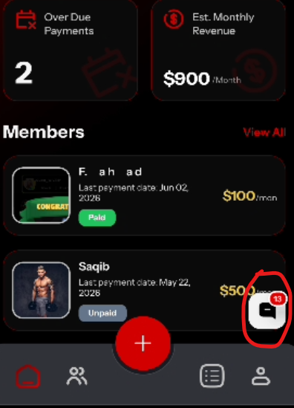
Still shows 13 when user already saw the chat
Bug_02:
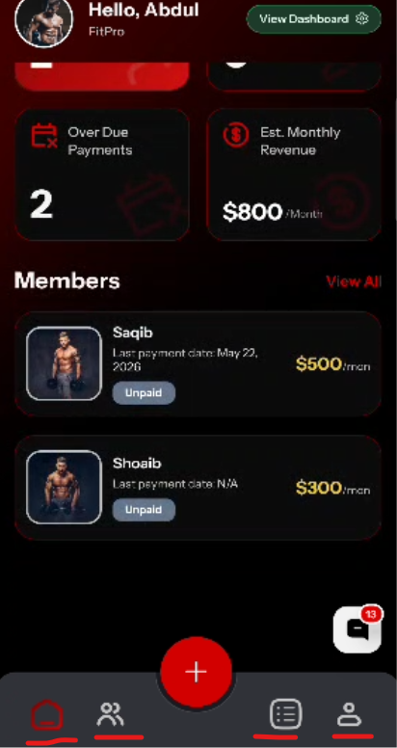
Navigation issue between buttons
Bug_03:
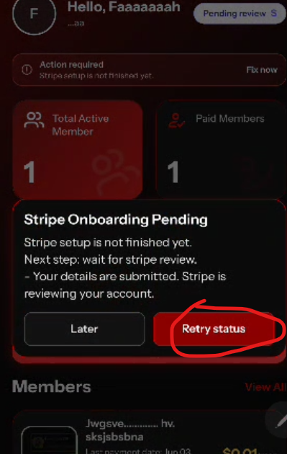
After Click on this button, nothing happens

